Analyzing and Writing about Art, #2

A few months ago you wrote about a famous photograph by Dorothea Lange, titled Migrant Mother, which depicted a woman staring off into the distance while two children bury their faces into her shoulders, shielding their faces from the camera. The point of looking at Art and writing about it is so that you can have more practice observing, analyzing and putting into words what your observations are. With practice, you will become a better writer across all subject areas and will help you become more observant and able to describe your thoughts.
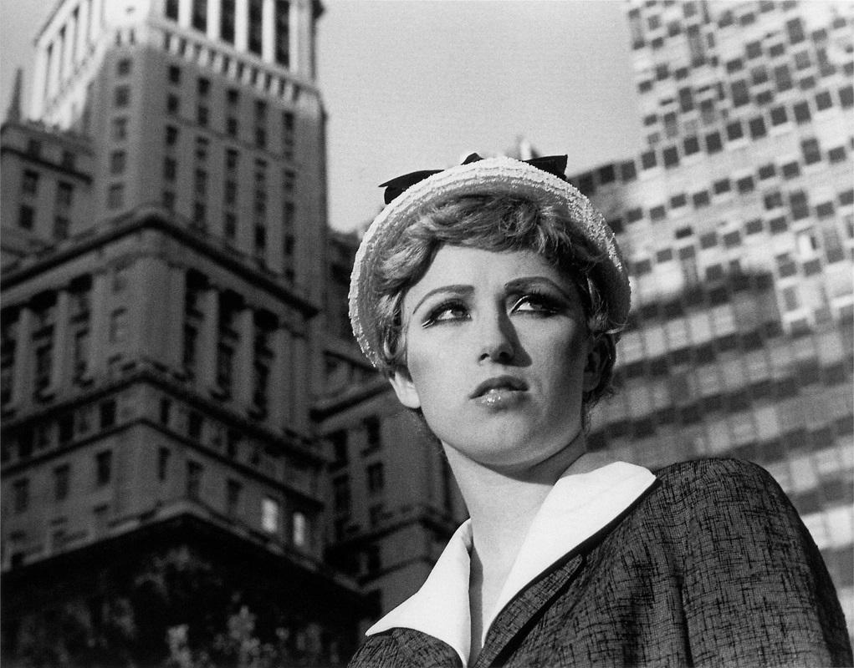
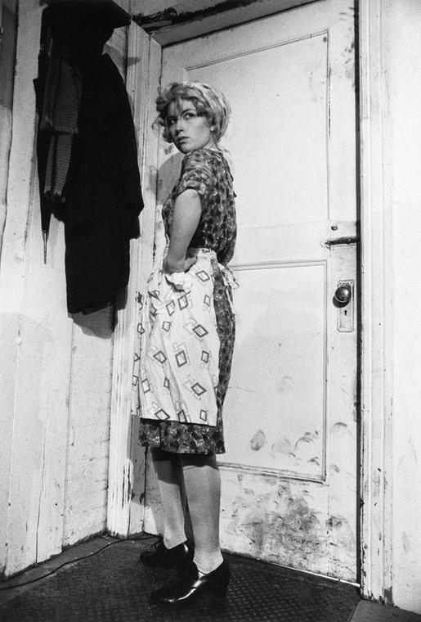

The two images above are taken by the same photographer, Cindy Sherman. In fact, both of these images are of Cindy Sherman.. Sherman uses herself as a subject/model in nearly all of her work. In the work above, she creates powerful images that are reminiscent of still frames from a movie or particular time period.

Just as in your science, English or math class, there are content-specific terms for art class. Some of these words are used across different disciplines (like mood, contrast, balance and emphasis). These vocabulary words can be helpful to more accurately describe artwork. Try to use some of these terms in your answers below.

When you are done answering the questions below, please upload this file to your Digital Photo folder in Drive.

contrast  leading lines  focal point  value | balance  proportion  composition  form | depth of field  aperture  shutter speed  point of view | emphasis  mood  rule of thirds  scale  repetition

Question 1: What are some of the artistic choices that Sherman uses to create drama in her portraits? Be sure to use art specific vocabulary in your response.

Question 2: Describe what you think is happening in the image on the left. Start with what you see, describing the image in detail, then make inferences about what you think is happening, and explain your thinking.

Question 3: Describe what you think is happening on the right. Start with what you see, describing the image in detail, then make inferences about what you think is happening, and explain your thinking.

Question 4: If you could give each image a title, what would you name them?
Image 1 title::
Image 2 title:

