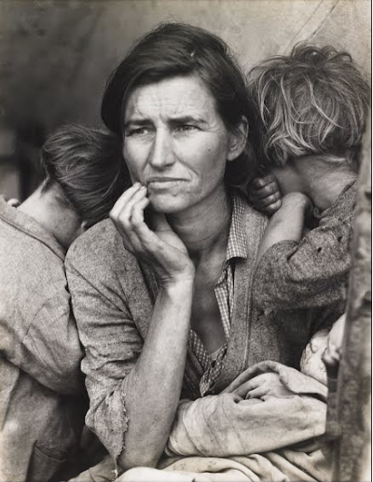
Digital Photo Visual Thinking #1

In this mini assignment you will look at art in a critical way and respond to a few questions. The goal is that it will give you practice thinking and writing about art and that over time, you will be able to write about art in a fairly sophisticated manner, using art terminology and technical camera techniques that you will learn this year.

Being able to look at art and write about it will help you in other areas of your life, too...it will make you a stronger writer, it will make you notice more details, not only in art but in everyday things, and it will make you more aware of the choices you have available to you as a photographer and artist.

Please take 10 minutes and answer the questions below.

- Look at the above photograph; What is happening in this photograph? Please describe what you see in as much detail as possible.

- What do you think the artist’s intent was?
(This means what the artist hoped to achieve with the choices they made with the photograph, what their overall goals were).

